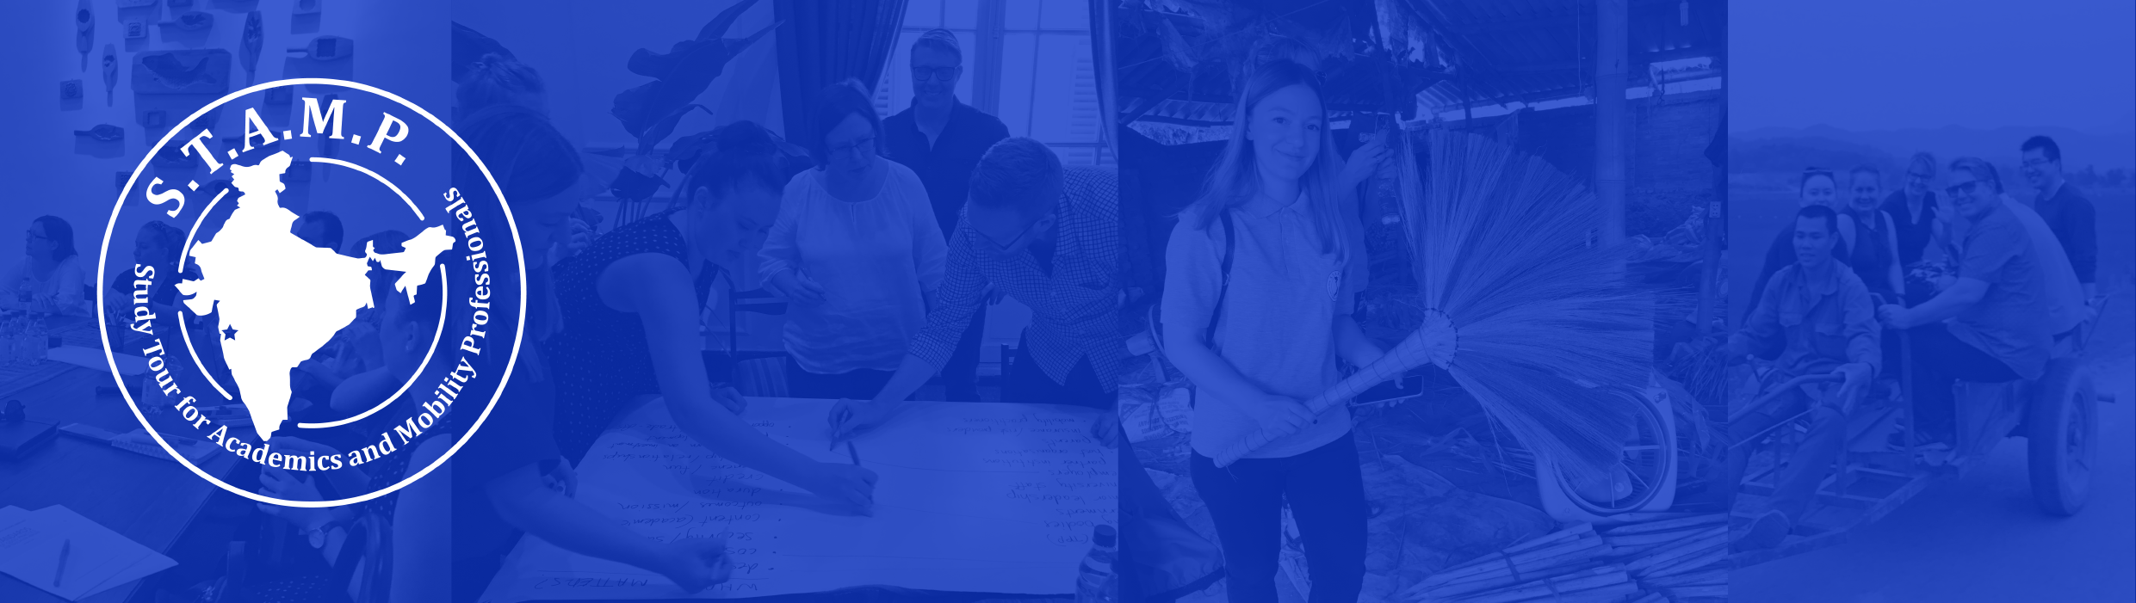
STAMP India
Study Tour for Academics and Mobility Professionals

t

Dear ____supervisor___________,

I am very interested in attending the Study Tour for Academics and Mobility Professionals (STAMP) program from 17 March - Friday 22 March 2019 in Mumbai, India. STAMP is a professional development opportunity aimed at building the skills of Australian university academic and professional staff that work with global mobility programs. This opportunity is directly related to my work as ___insert role/job title______ and is an opportunity for me to gain best-practice and theoretical knowledge with professional & academic peers and thought-leaders in the international education sector.

What I will learn
During this program, I will join a range of cultural and educational experiences and interactive workshops led by local partners, content experts, and experienced mobility professionals. These opportunities are designed to provide experience and knowledge of:
- Designing immersive, innovative, and practical international experiences
Types of activities
Workshop
A facilitated, interactive session with actionable outcomes and examples of best practice from the field.
Dialogue
A chance to share ideas, approaches, tools or thoughts on a designated topic.
Case study
Situational problem solving and role playing as mobility stakeholders.
- Key safety and risk concerns for global mobility programs, and effective risk management
- The logistics and coordination of global mobility programs
- Potential program partners and their perspectives as local partners coordinating global mobility programs through workshops and networking opportunities
- Community building and the chance to create a shared language and understanding of global mobility, experiential education, and project-based learning
- Innovative and new approaches to international education and student mobility
- ​Open Dialogues – a chance for all participants to share their own organisational approaches and present their best practice, troubleshoot challenges, and gain a toolkit to support their work.
Cost breakdown
Program Fee  Includes program registration, single room accommodation, most meals | $1200
Flight (estimate) | $800
Additional travel, meals, and incidentals | $300
TOTAL | $2,300

Further information:
Building on a successful 2018 pilot program in Vietnam, STAMP 2019 will take place in Mumbai, India. This study tour experience in South Asia provides participants with a chance to better understand the global student experience through meeting with community hosts to understand their requirements and the impact of hosting students and understanding safety, risk, and logistical considerations for developing sustainable immersive education programs.
STAMP is an interactive and peer-led program, with expertise being shared by all participants. The immersive nature of this trip aims to build a strong community of practice among Australian student mobility professionals, create personal connections and share challenges and best practice to support the design and development of global mobility programs.
Past participants Include:

- Student Mobility Managers
- Research Associates
- Associate Director – Outbound Short Programs
- Manager, Asia Development
- Senior Manager, Partner Development
- Internationalisation Officers
- Marketing Coordinators
- Mobility Coordinators

“STAMP was an incredible chance to ‘practice what we preach’ when it comes to international education. The insights and richness of an immersive program was a true highlight. Whether structured sessions or the chance to compare approaches over a bowl of noodles. It was great to get insights on study tour design, engaging in Asia - but the real feature of the program was the peer-learning. I finished the program with, not only a great network of professionals working in the field, but genuine friendships. I strongly recommend STAMP to all international professionals. Do it!”

- Lecturer, University of Melbourne

Thank you for your consideration,

__Full Name_____
___Job Title_____
___ Signature____

Program Partners

